

The Arab American University
Faculty of Information Technology

Attendance Tracking Using QR

By:
Layan Khalil Ibrahim - Major: Computer Science
Yaqeen Rami Alsadi - Major: Computer Science
Raheeq Daraghmeh - Major: Computer Science

Supervisor:

Dr. Amjad Ratrout

Table of Contents
Abstract ………………………………………………………………………………… 4
Project Objectives………………………………………………………………………..4
Project Workflow………………………………………………………………………....4
Ethics………………………………………………………………………………………….6
The system development process………………………………………………...10
Software process model…………………………………………………………….…11
Process Activities…………………………………………………………………..……14
Coping with change…………………………………………………………………….16
Process Improvement…………………………………………………………………17
Agile Methods…………………………………………………………………………….22
XP and Agile principles…………………………………………………………..……23
Plan-driven and Agile Development……………………………………………...27
Story…………………………………………………………………………………………...28
Refactoring…………………………………………………………………………………29
AI in Refactoring………………………………………………………………………….31
Test case Description…………………………………………………………………..33
Functional and non-functional requirements………………………………….34
Ethnography………………………………………………………………………………….35
Agile project management …………………………………………………………….36
Scaling Agile Methods……...…………………………………………………………….37
The Requirements Engineering …………..……...………………………………….40
The Requirements Engineering process ……...………………………………….42

Requirements Specification ..……………………...………………………………….43
Requirements Validation……………………………...………………………………….45
Requirements Changes ……………………………...………………………………….47
Context Models...………………………...……………...………………………………….51
Process Models ...………..……………………………...………………………………….53
Interaction models ...…...……………………………...………………………………….54
Structural models...……...……………………………...………………………………….55
Behavior models...………...……………………………...………………………………….57
Model-Driven engineering..……………………………...………………………………….58
Architectural Design...……………...……………………...………………………………….59

Abstract
Attendance is an important aspect in the management of any institution, however, it is often difficult to track and keep organized at times due to human error, time consumption and attendance data being prone to manual errors. In this project, attendance systems based on QR Code technology would be Implemented to automate the process of attendance tracking. This will be beneficial as it is accurate and efficient. Students simply can record their attendance by scanning their QR Code through a friendly interface. The goal of this project is to make the attendance tracking system easy and effortless while minimizing human errors as well including: automating the registration process to save more time for students and teachers, maintain the authenticity and correctness of the attendance data, enhance the organization of the data by managing it on a single database, and most importantly create a simple interface which is intuitive for every user.

System Workflow
QR Code Generation: Every course has a unique QR Code that includes basic details about him/her.
Scanning for Registration: Students are issued a QR Code to scan using a device, usually a teacher’s phone or another designated device.
Instant Update: The data is directly saved on the centralized database and takes no time at all.
Reporting: Detailed tuned attendance reports are produced without difficulty and always in a timely manner.

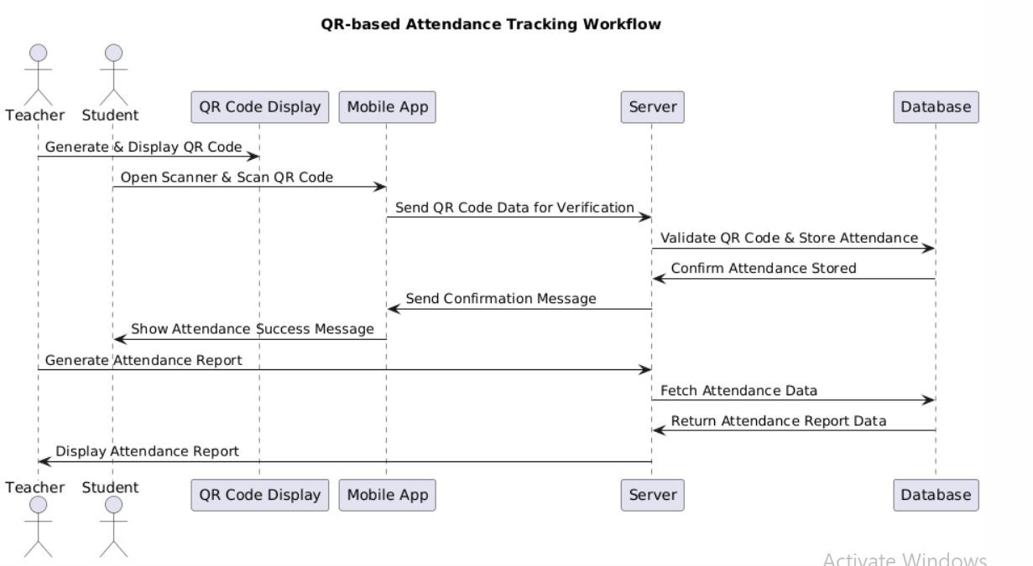

Project Objectives
- 📌 What do we aim to achieve?
- Automate the attendance tracking process
- Minimize human errors and fraud
- Provide real-time attendance records
- Generate attendance reports
- Ensure data security and privacy

Ethics

This paper outlines strategies for tackling the legal and ethical issues related to software engineering. Among the primary design goals for this system is respect for all parties involved, as well as ease of use and transparency. The key general aspects of this project with respect to the ethical principles are discussed further.
1. Public
Software engineers shall act consistently with the public interest.”
The goal of the present project is to improve the effectiveness of the educational process, therefore helping the public.
The system employs QR Code technology as a more effective means for dealing with attendance and consequently saving teachers’ and students’ valuable time that could be spent more efficiently.
Human errors are expected to minimize with this project, timing and maintenance of attendance is expected to increase effectiveness, improvement of the organization of processes within a school is beneficial as a whole to the education system.

2. Client and Employer
“Software engineers shall act in a manner that is in the best interests of their client and employer consistent with the public interest.”
The system is intended for educational purposes like Primary and Secondary schools as well as universities.
Client needs are met (educational institutions) by targeting ease of use, safety and correctness of tracking attendance.
The proposed system is created to suites the strategies and aims of the organization for which the system is to be developed and deployed.
3. Product

"Engineers cannot just comply with better concept laws, they have to strive to meet as international requirements as possible."
The binding translation incorporates modern practices through effective systems such as QR Code and data encryption practices.
The system has designed its interface so that all stakeholders: students, teachers, and administrators can easily navigate through it.
Different environments are employed in system testing, and a focus is put to ensure all bugs have been rectified making it free of errors.

4. Judgment
Purpose of the introduction and code is to train and practice on how to make effective logic decisions as an engineer."
In all stages of system development, engineers are deeply concerned with ethics and professional values.
Best practice and professional ethics guides and determines technical decisions taken in order to achieve a robust and secure product.
The implementation of the system is in such a manner that all the stakeholders are able to monitor its operations and how it is used.

5. Management
“In the management of software development and maintenance, Software Engineering Manager and Leaders shall adhere to such an ethical approach and principles.”

Project management’s responsibility is to carry out moral beliefs to facilitate the efficient execution of the system.

Clear procedures for the system life cycle, including design, development, testing, and deployment, are supported within specified timeframes and quality standards.

The staff is tasked with joining forces and working in concert towards the project objectives.
6. Profession
“In the course of the performing professional activities, software engineers shall bear in mind and strive for the preservation of the integrity, credibility and respect of the profession.”

The project under consideration emphasizes the significance of software engineers in enhancing the educational process which makes a positive impact on the reputation of the profession.

It shows how technology can be employed in the solution of practical problems of everyday life.

Transparent, fair, and ethical design of the system contributes to the establishment of confidence in the exsiting capabilities of the software engineers.
7. Colleagues
“Software engineers shall be honest and constructive in all their interactions with other software engineers.”
The system is developed such that each of its stakeholders (developers, teachers, administrators) are able to work together towards the goal of the project.
Teachers and staff receive training and on-site technical assistance to help them in the effective application of the system.
Bringing creativity and new ideas to the project is also done through sharing knowledge and ideas within the team.
8. Self

“Software engineers shall engage in lifelong learning activities relevant to their evolution as professionals, and in that vein, they shall adopt an ethical perspective in all activities.”
Such advanced technologies as QR Code and encryption are planned to be used in the project, which certainly will increase the skills of the team and lead to learning.

By sticking to an ethical code during the entire project improves the team’s ability to solve problems associated with the project along with the ability to manage it.
The project aims at motivating searching for different and new technologies for improving and perfecting the system in time.

The System Development Process
A well – defined software process is utilized in the development of the ClassQR Attendance System. The main steps include:
- Specification:

    - Utilization of QR codes to ease the morning attendance process.

    - Complete attendance and its information input and management.

    - Information of attendance of learners during lessons should be available at any time.
- Design and Implementation:
A user-friendly interface integrates a QR code display for teachers, allowing students to scan it upon entering the class. The system includes a QR code reader, centralized storage, and automated attendance registration to enhance accuracy and usability.

- Validation:
Ensuring the system operates as intended by:
    - Testing the accuracy of attendance recording.
    - Checking the reliability of real-time data updates.
    - Verifying user satisfaction through feedback from educators and administrators.
- Evolution:
Adapting the system based on:
    - Changes in institutional requirements.
    - Feedback from users to improve functionality.
    - Scaling to accommodate more users or new features.

Software Process Model
According to the incremental development model proposed by the Class QR system, it encourages feature flexibility and rapid development and deployment. This model incorporates aspects of several process models, namely:

- Waterfall Approach:
Beginning phases with the activities of requirements collection and system design.
Incremental Development:
Comprehensive stages such as requirement engineering, configuration specification construction, realization of the solution, client acceptance, deployment, modification and maintenance.
Integration and Configuration:
Leveraging reusable components for database management and QR code generation tools to reduce cost and deployment time.
Advantages of the Approach
Understandable initial planning for system objectives and requirements.
Incremental Benefits:
Usage of QR code and existing database libraries to liquefy the development of the applications
Delivering simpler and quicker services because of using parts and components libraries.
Requirements Specification:
Elaborate on the features for attendance, the interface, and the integration with the database.
Software Discovery and Evaluation:
Search and try out new methods and existing tools that deal with QR codes and databases.
Requirements Refinement:
Utilize the suggestions of system users and optimize the features within the system.
Application System Configuration:
Adjust the system in a way that it can accommodate different sizes of classrooms and various academic calendars.
Component Adaptation and Integration:

Integrate the design tool interface with the QR code generator and database storage plugin into the system.
Potential Challenges and Solutions.
Invisibility of the Process:
Besides minor losses, the silent progression of loss from changes may be problematic. Solution: Ensure that all stakeholders receive updates and reports as regularly as possible.
Degradation of Structure:
System loss and collapse of the permanent structure make tampering with it, without prior authority, to be dangerous. Solution: Schedule time for code cleaning and quality checks to be done.
Requirement Compromises:
While it is important for user needs of functionality to be met and technical needs only met in such certain levels. Compromise solution: Ensure that core prerequisites are implemented and the rest set aside for later updates.
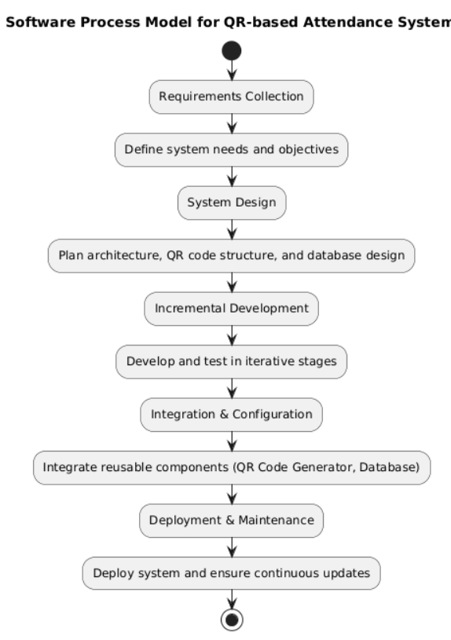

Process Activities
requirements engineering process:
- requirements elicitation and analysis :
This is the stage where we will understand what do the system stakeholders require or expect from the system.
professors:
Will they take attendance on a daily basis or not?
Is it inside the lecture or outside?
What is the time period allowed for registration?
students:
Will each student have a separate QR or is there going to a single QR for all the students?

developers:
What is the maximum number of students in some lecture?
- requirements specification:
“Each batch of the students is going to use one QR and this QR will be used for certain time during the lecture as is preferred by the teacher. This is going to be the scope of the lecture as will be displayed onto the display screen. Also, a QR will be provided, as much so as it is pressed into the hands of the teachers, who may choose to use a QR as often as daily for the purpose of taking attendance. It will be teachers’ decision as to how many students will use the QR.”
requirements validation:
After collecting data from the students and the teachers along with the developers, a meeting will take place to confirm that everyone’s requirements are met, the project offers good security, efficiently saves time and effective in terms of speed.
- Architectural Design
1.Server:
Server: processing of QR code scanning requests.
Store information in the database.
Create reports.
2.QR Reader:
Mobile phone camera

- Database Design:
1.students:
StudentId
StudentName
Department
2.Attendance:
AttendanceId
StudentId
Date
Time

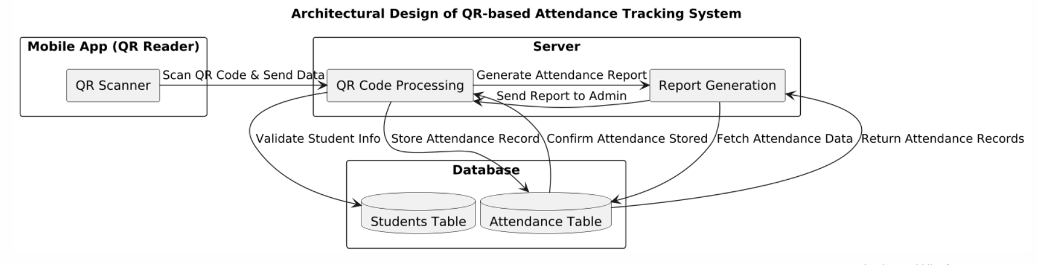
- user interface:
1.External : the screen where the scanner is located.
2.Internal :The database organizes the statistics of the attendance reports.
Coping with change

change is inevitable in all large software projects
Coping with change change is the core characteristic of all large software projects Change is Inevitable in All Large Software Projects That a diagnosis is offered. For instance, the university may wish to include faculties in attendance monitoring at some times of the day, introduce new systems like facial recognition in addition to QR codes, or interface with other applications such as the academic calendar or grading systems.
Business Changes Lead to New and Changed System
Requirements Over time, new requirements may emerge to meet the evolving needs of the university. For instance, detailed reports on student absences or automated notifications for students about their attendance might be needed. Additionally, university policies on attendance may change, requiring system adjustments to track attendance in specific courses or adding geolocation-based attendance checks (e.g., verifying that students are on campus or in a specific location).
New Technologies Open Up New Possibilities for Improving Implementations
As technology advances, new tools and approaches such as facial recognition or mobile app integration for tracking attendance may become viable. These technologies can be gradually incorporated into the existing system to improve functionality, performance, and the user experience, ultimately benefiting both students and staff.
Changing Platforms Require Application Changes
Changes in the underlying platforms (e.g., moving to a cloud-based system, supporting new devices, or upgrading operating systems) may require modifications to the system's architecture. For instance, if the system is moved to a cloud platform, the backend infrastructure will need to be adapted for scalability and integration with cloud services, ensuring smooth operation.
The Costs of Change
Introducing changes—whether new features or system adjustments—incurs costs, including rework such as reanalyzing requirements, updating the codebase, and performing additional testing. It’s important to account for these costs during the planning phase to ensure that changes are managed effectively without disrupting the project timeline or budget

Process Improvement
- Process Measurement :
- Focus Areas :
  - Efficiency: How fast can attendance data be recorded and processed?
  - Accuracy: Are there errors in capturing or storing attendance records?
  - User Experience: How intuitive is the QR scanning process for students and staff?
- How to Measure :
  - Time taken to register attendance for a batch of students.
  - Frequency of system errors (e.g.,unscannable QR codes or database conflicts).
  - User feedback surveys on ease of use.
- Process Analysis :
- Identified Weaknesses :
  - Possible delays in scanning large groups simultaneously.
  - Risks of unauthorized access to the centralized database without encryption.
  - Challenges in integrating the system with future technologies (e.g., facial recognition or geolocation).
- Proposed Solutions :
  - Introduce batch processing for QR codes or allow simultaneous multi-device scanning.
  - Strengthen encryption protocols to ensure secure data storage and transfer.
  - Modularize the system to make it easier to integrate with new features.

- Process Change :
- Short-Term Improvements :
  - Add QR code redundancy checks to avoid scanning errors.
  - Implement real-time alerts for failed scans or anomalies in data entry.
- Long-Term Improvements :
  - Move the system to a cloud-based platform for scalability and easier data sharing across institutions.
  - Develop APIs for integration with other systems, such as student management or grading platforms.
  - Introduce analytics tools for attendance trends, enabling predictive insights for administrators.

How Agile model can be integrated inside the project ?
Integrating the Agile model into your Attendance Tracking Using QR project requires restructuring the development process to align with Agile principles and practices. Here's how it can be effectively implemented:

- Identify Agile Framework
Choose an Agile framework suitable for your project:

Scrum: If your team prefers time-boxed iterations (sprints) with structured roles.
Kanban: For a flow-based approach that focuses on visualizing tasks and continuous delivery.
- Set Up Agile Workflow
A. Define Roles
Product Owner: Responsible for gathering requirements, managing the backlog, and prioritizing tasks (e.g., the team lead or stakeholder representative).
Scrum Master (Optional): Facilitates Agile practices, removes obstacles, and ensures smooth workflow.
Development Team: Focuses on coding, testing, and delivering working increments.
B. Break Down the Project into User Stories
Create user stories that represent specific functionalities or stakeholder needs. Example:

"As a teacher, I want to generate a unique QR code for each class so attendance is efficient."
"As a student, I want to scan a QR code quickly so my attendance is recorded."
"As an admin, I want to access detailed attendance reports to monitor student participation."
- Implement Agile Iterations
Sprint Planning
Divide the project into sprints (2–4 weeks each).
Define sprint goals by selecting a subset of high-priority user stories from the backlog.
Example Sprint Plan for the Project:
Sprint 1: Implement QR code generation and basic scanning functionality.
Sprint 2: Integrate the database to store attendance data.
Sprint 3: Develop attendance reports and admin dashboard.
Sprint 4: Enhance the user interface and add security features (e.g., data encryption).
Daily Stand-Up Meetings
Team members report:
What they accomplished yesterday.
What they plan to work on today.
Any blockers they are facing.
Deliver Incremental Features
At the end of each sprint, deliver a functional increment of the system for stakeholder feedback. For example:

After Sprint 1: A working QR code generator and scanner.
After Sprint 2: A functional database storing scanned attendance data.
- Continuous Testing and Validation
Apply Test-Driven Development (TDD):
Write test cases for each feature before implementation.
Example: Test whether QR codes are unique for each student.
Perform User Acceptance Testing (UAT) with teachers and students to ensure the system meets their needs.
- Foster Stakeholder Collaboration
Conduct Sprint Reviews:

Demonstrate completed features to stakeholders.
Gather feedback on functionality and usability.
Involve stakeholders in the requirements refinement process to ensure the project aligns with their evolving needs.

- Adapt to Changes
Agile thrives on flexibility. Use feedback from sprint reviews to:

Adjust priorities in the product backlog.
Introduce new user stories (e.g., adding geolocation or facial recognition for attendance).
- Use Agile Tools
Trello or Jira: For managing the product backlog and tracking sprint progress.
Slack or Microsoft Teams: For team communication and daily updates.
GitHub or GitLab: For version control and collaboration.
- Measure Progress
Use Agile metrics such as:
Velocity: Measure how much work (in story points) is completed each sprint.
Burndown Chart: Track sprint progress and remaining work.
Integration Example
System Workflow in Agile
Sprint 1:
Develop a QR code generation system.
Test scanning functionality on teacher devices.
Sprint 2:

Create a centralized database.
Implement automated attendance recording.
Sprint 3:
Build reporting features for administrators.
Refine the user interface based on feedback.
Sprint 4:
Add security measures (e.g., data encryption).
Prepare for deployment and conduct final testing.

Agile Methods

Rationale for introducing Agile methods into the development of this project stems from criticism of existing clunky methods. Such methods:
Concentrate on offering functional features (like QR code scanning) instead of getting too caught up with the aesthetics of the system.
Employ a cyclical model of software development leading to refinements of the system.
Prospect to create a functioning attendance system in the shortest possible time and then improve on it based on user requirements.
Agile methods in a nutshell are designed to eliminate work that does not add value (e.g. over documentation) and ensure that developers do not have to rework much in response to requirements changes.
We are revealing more effective methods of creating this attendance system by constructing it and having educators and students partake in the process. In this work, we have come to appreciate:
Self-organizing teams over processes or even tools
Working systems over detailed designs in a waterfall model
Educators and students over a contractual approach
Feedback and changes over the plan.
Despite our appreciation of the traditional approaches, we believe in flexibility, collaborative approach and functionality of the system.
For this project, Agile methods enable us to:
Facilitate faster rollouts and enhancements for QR code generation and attendance report generation.

XP and Agile principles
What is the way to implement the agile model towards our project?

1. Features, Agile Project Control, and Incremental Development.
•Splitting Up Into Sprints: In the sprint achieve the project elements over a set period of at least 2 weeks or at most 4 weeks.
•Feature Evolution: Make the product backlog of features and arrange them in terms of value and risk.
•Sprint Goal Definition: Decide on the approach to be used before the commencement of each of the sprints.
•Forum Avoidance: Having finished the day’s or yesterday’s work, hold daily briefings to get progress, blockages and fusions all discussed.
•Agenda Setting Retreat: Get back together and have an in-depth review of the work done at stakeholder level and get feedback for improvement.
•Deliver Review: Carry out an internal assessment on the sprint for growth purposes.

2. Flexibility and Adaptability
•Alteration: Adjustment of the change in the requirements or feedback ought to be avoided.
•Betterment: Improvement ought to be promised by developing the process every so often.

3. Collaboration and Communication
•Separation: Thoughts of the designers, testers , help the developers to integrate with key stakeholders.
•Unreserved Relations: Elimination of unreserving communication on the commence, with the rest of the team practice.

•Cycles of Feedback: Adopt regular feedback systems to facilitate and defend the project as well as the work supplied
. 4. Importance of Value
- Providing Value Earlier Through Value Creation
5. Agile Practices for Your Project
•User Stories: Write user stories that illustrate how the system should function according to its users.
Example: “As a teacher, I would like the system to be able to scan student QR codes for easy attendance so that I can measure students’ participation accurately.’
•Task Boards: Make use of a task board (physical or digital in case you are outside the office) to manage the workflow and measure how much, and how fast these tasks get done.
•Automated Testing: Run automated tests in order to validate the code quality and avoid bugs.
•CI/CD: Conduct the revisions that come with setting up a CI/CD framework that removes build-test-deploy silos.

Extreme Programming (XP) Techniques and their Relevance to QR Code Attendance Tracking Project

1. Core XP Practices
Planning:
User Stories: Work together with your stakeholders (teachers, administrators) for adequate understanding of user stories for the system. For instance, when I am a teacher, I want to quickly scan incoming students with QR codes to take lists of participants in the class.
Release Planning: Create a general strategy of the entire project and make segmentation into smaller steps (sprints) plans.

Iteration Planning: Before the start of the sprint, work out the user stories or features that will be implemented.

Improvement:
Pair Programming: Same issues are dealt with simultaneously, as two developers are collaborating on the same code which is continually reviewed.
Conduct a TDD approach which is Test-Driven Development, this method requires that code is tested even before it is written so that the code developed conforms to the requirements that have been set.
Continuous Integration means that developers integrate their code into a common repository and build it on a daily basis so that issues can be discovered and dealt with as early as possible.
Refactoring is process of cleaning code and restructuring its design and architecture while retaining its behavior.

Design:
A common rule of thumb is to strive for a design that is as simple as possible and to avoid adding unnecessary complexity to the system, it is called This is a Simple Design.
Refactoring is changing code in such a way that it improves design and makes the code more manageable.

Communication:

This is the communication that the team members or the stakeholders intend to encourage as it is beneficial for all parties for sharing knowledge and experiences.
Communication is one of the key tools that Team Members use to improve their trust and understanding of the system and other members.
Customers are part of the team and remain active members of it throughout the development of the system so that at the end of the process the system developed addresses their requirements
. 2. Applying XP to Your Project

- Reality is different from expectations, therefore persuasion is required. So reach out to the stakeholders and persuade them to tolerant some sort of a steering wheel in the development process.

- Interact with them during the development process to eliminate the issues that can arise in accordance to the requirements that need to be integrated to the development of the system

- Opening up about the attendance tracking system is crucial, as their expectations would help to create realistic user stories for the modules.

- Creating multiple entertaining modules would require time and devotion so it would be beneficial for the developers to work in pairs on the project.

- Pair programming not only ensures that tasks are completed faster, but minimizes the gaps left by individuals working separately.

- Other developers can review their code, and testing the new features of the newly developed system helps in minimizing code quality issues and helps rather enhances the system quality.

Plan-driven and agile development
While plan-driven and agile approaches might seem contrasting, they can be effectively combined to leverage the strengths of both. Here's how you can apply this hybrid approach to your QR code attendance tracking project:
1.Initial planning
- Define Scope and Requirements: Clearly outline the system's objectives, features, and constraints. This might involve detailed use cases, system architecture diagrams, and data flow diagrams.
- Risk Assessment: Identify potential risks and challenges, such as integration with existing systems, data security, and scalability.
- High-Level Timeline: Create a rough project timeline, breaking down major milestones.
2.Iterative Development
- Sprint Planning: Divide the project into short sprints (e.g., 2-4 weeks).
- Prioritization: Prioritize features based on value and risk, using techniques like MoSCoW method (Must have, Should have, Could have, Won't have).
- Sprint Execution: Follow agile practices like daily stand-up meetings, pair programming, and test-driven development.
- Retrospectives: Conduct regular retrospectives to learn from past sprints and improve the process.
3.Continuous feedback and adaption
- Regular Demonstrations: Regularly demonstrate progress to stakeholders, gathering feedback and adjusting the plan as needed.
- Risk Management: Continuously monitor and mitigate identified risks.
- Flexibility: Be prepared to adapt to changing requirements or unexpected challenges

A story

One QR will be available for each section. If the teacher decides to take attendance, a user interface will appear containing a QR scanner that will be available for only a few minutes, so that absent students cannot record attendance from a previously taken photo of the scanner. All students in the hall can record their attendance by photographing the scanner with the phone camera, whether for iPhone or Samsung. Once this happens, the teacher will see a list of the names of the students who have recorded their attendance, along with their university numbers and the time of registration.

When the scheduled time for registration ends, the teacher will press the "Save" button to record the attendance data for the students. If the student is absent, a message will be sent to the student to inform him that he has been recorded as absent.

On the other hand, the data modification process will be smooth if the student has a medical or other excuse, and the student will also be informed that the absence will be removed on this dateOne QR will be available for each section. If the teacher decides to take attendance, a user interface will appear containing a QR scanner that will be available for only a few minutes, so that absent students cannot record attendance from a previously taken photo of the scanner. All students in the hall can record their attendance by photographing the scanner with the phone camera, whether for iPhone or Samsung. Once this happens, the teacher will see a list of the names of the students who have recorded their attendance, along with their university numbers and the time of registration.

When the scheduled time for registration ends, the teacher will press the "Save" button to record the attendance data for the students. If the student is absent, a message will be sent to the student to inform him that he has been recorded as absent.

On the other hand, the data modification process will be smooth if the student has a medical or other excuse, and the student will also be informed that the absence will be removed on this date

Refactoring

Refactoring could help us in different ways:

Database Design:

Apply normalization thanks to new tables (for instance, divide this single Attendance table into Students, Classes and AttendanceRecords).
Enhance the performance of the queries through indexation of the frequently used searching fields.

Graphical User Interface:

Distribute the UI logic into different modules with different purposes (for example, one will scan the QR code while the other will display the attendance info).
Enhance the interaction design for better usability.

QR Code Generation Logic:

Modularize the QR generation/scanning to protect the core logic from blocking errors.
Add a possibility to scan large groups for a single QR code in a batch process.

Security Additions:
Move encryption and input validation of sensitive data into one central corner.

Quality Assurance:
Make unit tests for the main functions which do core tasks ranging from QR generation to attendance recording.
Write automated tests for standard tests in order to try to achieve some edge tests like duplicate codes or duplicates.

Architecture Expansions:
For larger works to be done, I would suggest changing architecture to the cloud supporting modular for ease of scaling like segregating the QR Code, Database and Reporting into different modules.

AI in Refactoring
Automated Code Creation:

QR Code Generation: If you’re looking for different innovative ways to create your QR Codes, instead of designing them, you can make use of AI powered tools such as Midjourney or DALL-E 2. This can improve the brand identity as well as the consumer experience.

2. Intelligent Code Completing and Refactoring:

Code Suggestion: If you want to take your development to a whole new level, then make use of AI based tools like GitHub Copilot and Amazon CodeWhisperer to suggest relevant code snippets while you type. This can speed up development time and chances of error.

3. Predictive Maintenance:

Code Analysis: In order to reduce the chances of bugs or any code problems in your system, you can now make use of AI powered tools to assess your code base. This aggressive strategy is useful as it minimizes errors and boosts stability of the system.

4. Automated Testing:

Test Case Generation: With the help of AI tools in your system, you are able to create test case structures while checking for multiple errors ensuring zero bugs in code. Yes, this may be time consuming, though, it saves a lot of time dedicated to coding instead of manual work.

5. Improved User Experience:

Personalized Recommendations: You can choose gestures powered by AI to gather the attention of users and consumers by looking at their interaction with the different features of the attendance tracking system. This can include work optimizations and other system integrations.

6. Security Improvement:

Anomaly Detection: AI powered tools provide solutions towards fraud detections related to attendance.

7. Data-Driven Insights:

Predictive Analytics: Use AI to analyze attendance data and predict future trends. This can help optimize resource allocation and improve decision-making

Test case Description
.
Use Case ID | Use Case Name | Description | Actors | Preconditions | Steps | Postconditions
UC-01 | Record Attendance via QR Code | A student scans a QR code to mark attendance. | Student, System, Database | - The student must have a valid QR code.  - The system must be active and running. | 1. Student scans the QR code.  2. System validates the QR code.  3. If valid, attendance is recorded in the database.  4. System confirms attendance. | - Attendance is recorded in the database.  - The student receives confirmation.
UC-02 | Handle Invalid QR Code | The system detects an invalid QR code. | Student, System | - The student scans a corrupted or non-registered QR code. | 1. Student scans an invalid QR code.  2. System verifies the QR code.  3. If invalid, an error message is displayed. | - Attendance is not recorded.  - The student receives an error message.
UC-03 | Prevent Duplicate Scanning | Ensures that the same QR code is not scanned twice in one session. | Student, System, Database | - The student has already scanned the QR code for that class session. | 1. Student scans a QR code.  2. System checks if the student is already marked present.  3. If duplicate, an error message is displayed. | - Attendance remains unchanged.  - The student is notified of a duplicate entry.
UC-04 | Generate Attendance Report | Teachers generate attendance reports for a session. | Teacher, System, Database | - Attendance data must be stored in the database. | 1. Teacher requests an attendance report.  2. System retrieves data from the database.  3. Report is generated and displayed/downloaded. | - Teacher receives the attendance report.  - Data is available for review.
UC-05 | Bulk QR Code Processing | Handles multiple QR code scans in a short period. | Student, System, Database | - A large number of students need to be processed. | 1. Multiple students scan QR codes.  2. System processes and validates each scan.  3. Valid records are stored in the database. | - Attendance for all scanned students is recorded in real-time.

Functional and non-functional requirements
requirements engineering is the basis of developing any system and also enters into the attendance and absence taking system using QR. By identifying and analyzing the system requirements

- ‏ functional requirements:
- ‏Scan QR codes to record attendance.
- ‏Save attendance data in database.
- ‏Send notifications when absent.
- ‏View attendance and absence reports

- ‏ non-functional requirements
- ‏Performance: Ensure that the system can handle a large number of users.
- ‏Security: Protection of users' personal data
- ‏Ease of use: The user interface should be simple and easy.

Ethnography

Ethnography is used to understand the context of the system, such as determining the interaction of students and teachers with the QR code. Through it, we will understand whether users face difficulty using the code and whether they prefer mobile phones or other smart devices. That is, by using ethnography, we can discover problems that did not appear during the project implementation process. By analyzing the obstacles, we will identify technical problems such as the type of code and whether it is compatible with all types of devices such as Android and iOS and whether the method of using it is understood by all users or not, as it works to improve the user experience by simplifying the user interface and adding educational instructions in the event that a user does not know how to use it.

Agile project management
Integration of Agile and Scrum Methodologies in the Attendance Tracking System Based on QR Code
Agile Methodology in IT Inventions Inc. project for this System
Purpose: To create and implement a cost-effective System for QR code-based attendance of the potential user of the software product within the specified time frame.
Method: A method of working guided by agile principles:

Smart engineer development: concentrate on producing functional units for a short period of time of 2 days.

Iterative development with constant feedback: Continuous delivery of working iterations of the system to collect responses from users.

Consumer engagement: Teachers and administrators are involved in the specification of requirements and feature validation.

Use of text minimization: Include as much as possible code and a minimal number of essential project documentation.

Systematic test-driven development: Designed to focus on the quality of code.

Agile methodologies enable ease of worry about all stages of project development, testing, deployment and maintenance thus lowering the amount of manual work when Scrum is implemented.

Scaling Agile Methods

Scrum Stages:
Planning phase:
Goals and objectives: To enhance the requirements already set in place, develop an attendance tracking system able to work with QR codes to eliminate any possibility of human errors capture.

Defining the system:
Back End: Provides storage for attendance logs
Front End: QR code interfaces for students
Integration: Bridges communication between the database and a scanner

Sprint Cycles:
First Sprint Cycle: components to develop student QR code ID generators
Second Sprint Cycle: components to create students QR code scanner modules with the function to
The smart portable scanners and QR codes registration systems will be developed with the related databases. A user will be able to quickly scan attendees present in the meeting and make certain controls over databases using the scanners. The system will consist of the following modules.
Provide Mathematics set of tools like calculation tools along with the scanning system to further develop features allowing easy controls of online math transactions to seamlessly manage project requirements.
Set up deadlines for all modules to divide time evenly for further developments to be able to reach the goals with just the right amount of allocation.
Make changes to the scheduled deadline to increase time allocation to coding the construction of the online tool to drive further use through user engagement allowing for an expansion in the end user market.
Ensure feasibility studies are conducted before selling the final product to the end user advice real users on integration problems and resolving them.
During the product development phase, foreign vendors will be engaged to assist in the resolution of integration issues and elimination of bugs.
Use automated integration methods combined with the help of foreign vendors for bug removal and to further enhance the system through automation.

The set JediMath which consists of tools focused on calculation to engaging features combined with the scanning tool expands the use cases across the project’s requirements along with further enhancing the value it provides to the end user.

Sprint Review:
Show the new increment to the interested parties and collect their feedback.
For Example: Present how the QR code scanning works and get the comments sorted out.

Sprint Retrospective:
Examine the performance of the team and recommend any amendments required.
For Example: “It is clear that communication with the product owner could be better to facilitate compliance with the requirements.”

Addressing Agile Challenges in the Project

Customer Involvement:

Continuously involve the educators in the project such that the actual use of the system in practice is realized.

Prioritizing Changes:
Employ a scoring system that assigns weights to a given task in order to determine its level of importance on the backlog list.

Team Collaboration:
Use daily scrum activities to enable team cooperation and visibility to occur.
Documentation Needs:

Keep information documents as brief as possible, while still obtaining sufficient and pertinent information that meets the requirements in relation to the long-term design goals.

Scaling Agile Practices:

In case the scope of the project increases, then a Multi Team Scrum should be implemented which has synchronized release schedules and arrangements for inter-team communication.
Benefits of Using Agile for the Attendance Tracking System
Manageable Increments: For every functional module, a production ready version of the software is provided during each sprint thus avoiding difficulties.
Early Feedback: Educators and administrators are able to provide feedback and suggestions because they have a sneak-peek at the work-in-progress.
Improved Communication: Because the majority of the work of the team is accomplished by the Use of Daily Scrums to reclaim the time essential in ensuring the team is coordinated.
Adaptability: Change is in the agile framework and thus new requirements can appear when examples are needed or even a feedback from the educators.

Enhanced Trust:
Regular updates and working increments build confidence among stakeholders.

The Requirements Engineering
This is a process of determining the services required for the ClassQR system, and the constraints under which the Class QR system must operate.

What is a Requirement?
High-Level Requirement: The system should enable QR code scanning that is seamless and real-time when monitoring student attendance.
Detailed Specification: A specific student's unique QR code found in the centralized database, which the system has to verify within less than one second.

Requirement Types
User Requirements
Example
"Teachers should be able to scan the QR codes of students for instant access to attendance information through either a mobile application or a tablet."
Description: Statements formulated at a high level in natural language; thus, these are meant for educators and administrators.
System Requirements
Example:
"The system must integrate with the institution's database to validate QR codes and store attendance records in real time."
Description: Detailed descriptions of the services and functions, serving as part of a development contract.
System Stakeholders
End Users: Teachers and students using the QR scanning application.
System Managers: IT staff maintaining the ClassQR system and ensuring smooth operation.
System Owners: School administrators responsible for approving the system.
External Stakeholders: Third-party developers or vendors integrating ClassQR with other systems (e.g., Learning Management Systems).
Functional and Non-Functional Requirements

Functional and Non-Functional Requirements
Functional Requirements:
- Students must have unique QR codes.
- Attendance data must be recorded in real time during scanning.
- The system should generate daily attendance reports automatically.
Non-Functional Requirements:
Performance: Attendance scanning should process QR codes in less than one second per student.
Reliability: The system should operate at 99.9% uptime.
Security: The QR of students and attendance records are to be encrypted when in transit or storage.
Usability: Teachers should be able to use the system, using less than two hours of training

The requirements engineering process
Requirements Elicitation and Analysis
Involved Stakeholders:
Teachers (the end-users) on use within their classes.
IT staff specify the constraints on integration with pre-existing databases.
Administrators give requirements on reporting.
Techniques Used:
- Interviews of teachers regarding the current problems in attendance
- Prototyping for demonstration of QR scanning
- Requirements Classification and Organization
- Group into functional (scanning, reporting) and non-functional (performance, security).

Requirements Specification
Requirement specification involves defining what the system should do and its operational constraints.
1.1 Functional Requirements
These define specific functionalities the system must have.
ID | Requirement
FR-01 | The system shall generate a unique QR code for each student.
ER-02 | The system shall allow students to scan their QR code to mark attendance.
FR-03 | The system shall store attendance records in a centralized database.
FR-04 | The system shall provide real-time updates to teachers on student attendance.
FR-05 | The system shall allow teachers to export attendance reports.
FR-06 | The system shall send automated notifications to absent students.
FR-07 | The system shall allow authorized administrators to modify attendance records.
FR-08 | The system shall support batch scanning to process multiple QR codes at once.

1.2 Non-Functional Requirements
These define quality attributes and constraints.
ID | Requirement
FR-01 | The system shall process attendance scans within 2 seconds.
ER-02 | The system shall have 99.9% uptime during school hours.
FR-03 | The system shall use AES-256 encryption to secure attendance data.
FR-04 | The system shall be scalable to handle up to 10,000 students simultaneously.
FR-05 | The system shall have a mobile-friendly interface for teachers and students.
FR-06 | The system shall allow role-based access control (RBAC) for different users.
FR-07 | The system shall be compliant with educational data privacy regulations.

Requirements Validation
Requirement validation ensures that the requirements are correct, complete, and feasible.
2.1 Validation Techniques
• ✅ Requirements Reviews: The document should be reviewed by developers, teachers, and students.
• ✅ Prototyping: Develop a prototype of the QR scanning and reporting module to get early feedback.
• ✅ Test-Case Generation: Validate that the system meets the required functionalities.
2.2 Key Checks for Requirement Validation
Check | Questions to ask
Validity | Do the requirements reflect what the stakeholders need?
Consistency | Are there any conflicting requirements?
Completeness | Have we covered all required functionalities?
Realism | Can these requirements be implemented with current technology and budget?
Verifiability | Can the requirements be tested?

2.3 Example Requirement Validation Scenarios
• Test Case for QR Code Scanning
- Scenario: A student scans their QR code within class time.
- Expected Outcome: The system registers attendance and updates the database.
- Test Result: ✅ Passed (Attendance recorded successfully) 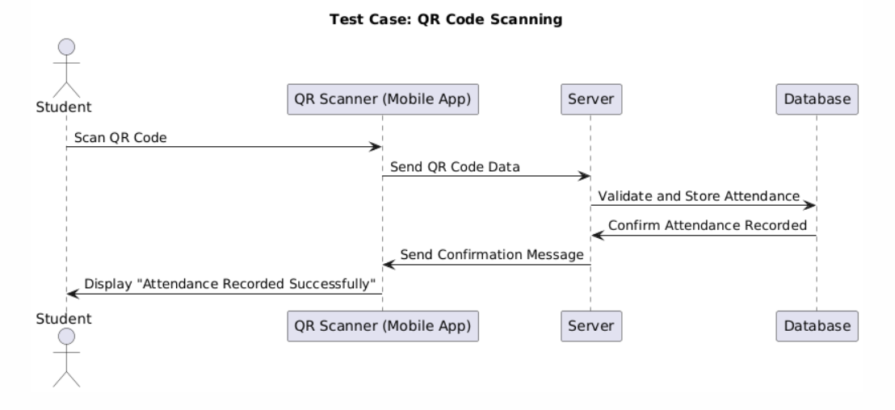

• Test Case for Attendance Modification
- Scenario: A teacher edits a student’s attendance due to an excused absence.
- Expected Outcome: The attendance log updates correctly, and the student gets a confirmation.
- Test Result: ✅ Passed (Modification reflected in the system)
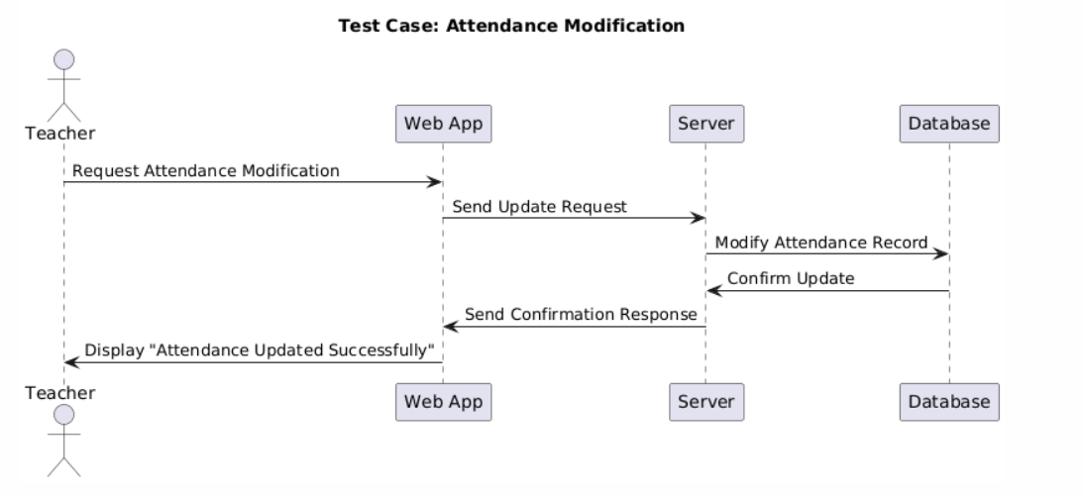

Requirements Changes
Requirement changes happen due to evolving user needs, technology shifts, or regulatory updates.
3.1 Common reasons for requirements changes
- Institutional policy changes (e.g., requiring biometric validation along with QR codes).
- User feedback (e.g., teachers requesting a feature to mark attendance manually).
- Scalability needs (e.g., adding cloud storage due to increased data volume).
3.2 Requirement Change Management Process
Stage | Description
Problem Analysis | Assess the need for change (e.g., is the current system failing to meet a critical need?)
Change impact analysis | Evaluate the effects on performance, security, and cost.
Approval Process | Decide whether to accept, modify, or reject the change.
Change Implementation | Modify requirements, update documentation, and adjust development plans.

3.3 Example of a Requirement Change Scenario
📌 Change Request:
The university wants to integrate facial recognition alongside QR code scanning to prevent fraud.
📌 Impact Analysis:
- ✅ Security: Improved fraud detection.
- ❌ Cost: Increased development costs due to AI implementation.
- ❌ Privacy: Requires additional compliance with data protection laws.
📌 Decision:
The change is accepted, but phased implementation is recommended (starting with QR-only, then adding facial recognition as an optional feature).

Use case Diagram :
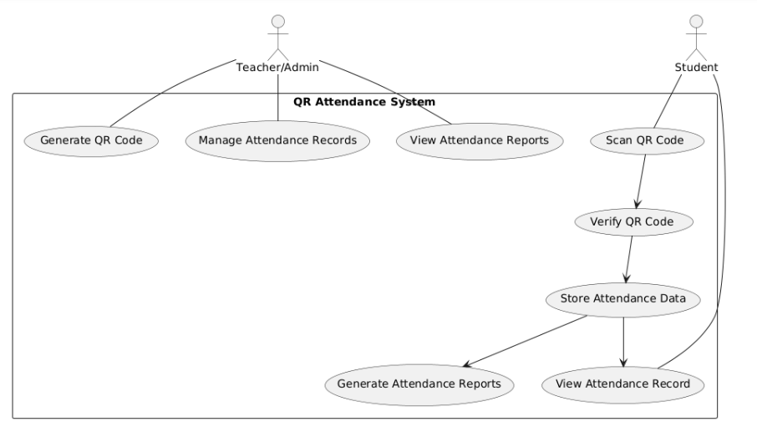
Explanation of use case diagram
- Actors:
  - Student: Scans the QR code and views attendance records.
  - Teacher/Admin: Generates QR codes, manages attendance, and views reports.
- Use Cases:
  - Scan QR Code → Student scans a QR code to mark attendance.
  - Validate QR Code → System verifies the scanned QR code.
  - Store Attendance Data → Attendance is saved in the database.
  - View Attendance Record → Students can check their attendance history.
  - Generate QR Code → Teachers generate session-based QR codes.
  - Manage Attendance Records → Admins modify or update attendance if needed.
Relationships :
- "Includes" (.> Relationship):
  - Scanning QR Code includes Validating QR Code.
  - Validation includes Storing Attendance Data.
- "Extends" (.> Relationship):
  - Stored Attendance Data extends Viewing Attendance Record (so users can check history).
  - Stored Attendance Data extends Generating Attendance Reports (for analysis).

Class Diagram :
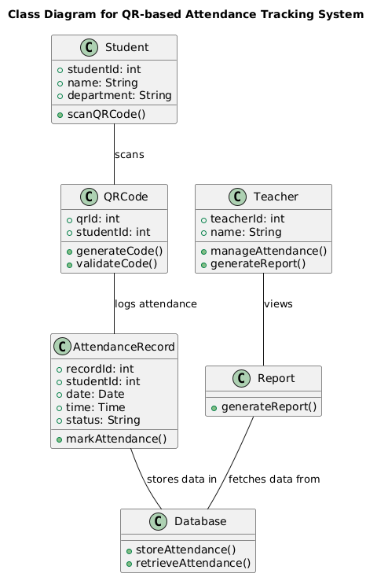
Explanation of the class Diagram :
- Student Class
  - Attributes: studentId, name, department.
  - Methods: scanQRCode().
- Teacher Class
  - Attributes: teacherId, name.
  - Methods: manageAttendance(), generateReport().
- QRCode Class
  - Attributes: qrId, studentId.
  - Methods: generateCode(), validateCode().
- AttendanceRecord Class
  - Attributes: recordId, studentId, date, time, status.
  - Methods: markAttendance().
- Database Class
  - Stores and retrieves attendance data.
- Report Class
  - Generates reports based on attendance records.

Sequence diagram
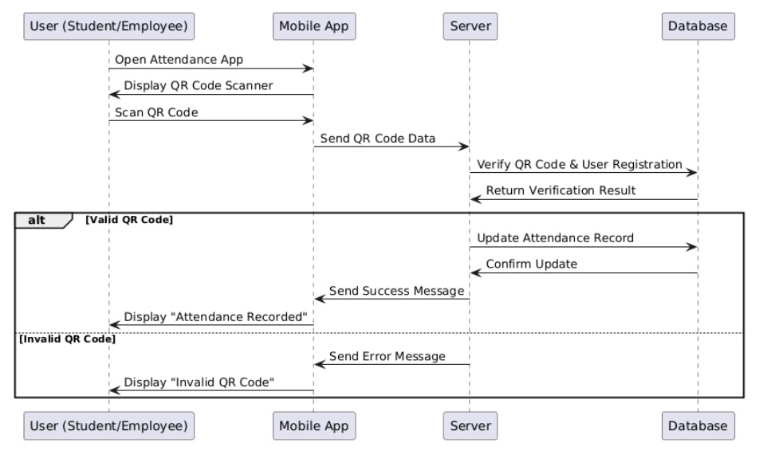

Context Models
They are tools used in software engineering to understand the relationship between the QR system and its surrounding environment, such as people and processes.
These models help define the boundaries of the system and illustrate how it interacts with these systems.
The limits of the system in our project are: teachers and students
Purpose of context models:

- first thing is for the system to generate codes QR
Scan these codes through students to register attendance
- Second thing it provides attendance reports for teachers

- The third thing is to be able to get the student's personal information such as the student's name and university number
- The last thing is to be able to link the code to the course
I have a contextual model for the attendance system through the code consisting of:
Student System: The system exchanges student data
Course system: by linking the course to the code allocated to this course
Reporting System: He is able to provide reports to teachers
We added a student information system: so that it is able to send a short message to students who are absent from the lecture
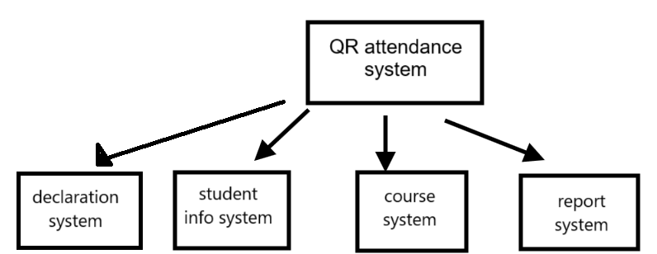

Process Models
The main processes in my project are:
The student enters the lecture
QR Scans Code
The systems make sure that the student is in the division
Attendance is recorded
Update attendance reports in the system
Potential challenges: First, there may be a delay in providing student data, so we must make sure that the system is running smoothly
Second thing make sure that student data is not used in other systems and this revolves around security and privacy

Interaction models
How the system interacts with users
Case Usage Form
Users: Students and Teachers
Uses: Scan code and produce attendance reports
QR students interact with the system by scanning the code
Teachers monitor attendance and can use the system to produce reports
Use sequence diagrams
The student scans the QR code.
The attendance system verifies the validity of the code.
Attendance is recorded in the database if the code is correct
Teachers can view attendance instantly.

Structural models
The components that make up the system and the relationships between them.
Category charts

UML Class Diagrams in
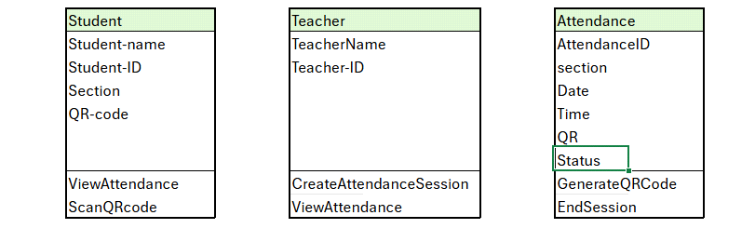Relationships between categories:
Student - Attendees:
1-to-1 relationship between student and attendance status in each session
Teacher-Attendee
1-to-multi relationship
Attendance-Code
1 to 1
Features of this model: First, simplicity and clarity
Tania Scalability Flexibility: Additional components can be added easily
Relations between categories are very clear
Generalization: Helps reduce redundancy in the system by grouping attributes and functions common to objects into a higher class
Grouping: Used to represent the relationships between the parts and the whole, for example: Each attendance session can include a group of students who have registered their attendance using QR, so there is an aggregation relationship between the attendance session and
Advantages of using generalization and assembly in the system:
Reuse, simplified maintenance, organization optimization

Behavior models
These models show what happens or should happen when the system responds to stimuli from its environment
Data-driven models: show sequences of actions involving processing input data and generating related outputs.
Example of a data-driven model in my project:
Data entered: Scan the code by the student.
Steps:
Code data is sent to the system.
The system verifies the data (match the attendance record).
If the data is correct, attendance is recorded.
The system sends confirmation to the student and teacher.
Event-based models: show how the system responds to internal and external events.
Initial status: "Waiting to attend".
Event (Stimulus): Scan QR code.
The following status: "Attendance Registration".
Event (Stimulus): Send confirmation of attendance.
Comparison between data-driven and event-driven models:
Data-driven models focus on how data flows across different processes and illustrate data processing step by step.
Event-based models focus on how the system responds to events, as the system moves from one state to another based on specific stimuli. Regarding data: It is the flow of data such as code scanning and attendance registration. Regarding events: It is conceivable that each event (such as "clearing code") leads to a change in system state, such as moving from "waiting for attendees" to "attendance registration".

Model-driven Engineering
Models can be used to describe the system in an abstract way rather than writing code directly.
Model-Driven Architecture
Multi-layer models can be applied by developing models in three main layers:
The arithmetic-independent model (CIM) represents the basic concepts you use in the system such as attendance, absence, students, and teachers and the relationship between them.
The platform-independent model (PIM) represents how the system works in practice without going into the details of the platform it will work on.
Platform-specific template(PSM): Create platform-specific forms These forms will then be converted into executable code on these platforms.
Automatic translations of forms:
Adapting to new technologies: if you decide to add new features to the system
(such as adding another type of QR or using new technologies),
You can modify basic forms
(e.g. PIM and CIM)
Automatically generate new modifications to platform-specific forms

Architectural Design

- ClassQR is designed to efficiently and smoothly handle student attendance tracking using QR code. The system architecture includes QR code generator, scanning module, central database, and reporting system. Entities are well organized in terms of their relationships to ensure smooth data flow and instant processing.
- Flexibility and Architecture In the early stages of development, ClassQR provides a broad architecture that takes into account scalability and flexibility. Since restructuring the entire system can be very expensive, the design focuses on modularity and adaptability to potential changes or improvements in the near future.*System Features in Architecture* -
- Performance: QR code processing has been optimized so that delays in real-time attendance tracking are minimized.
- Security: Sensitive student data is secured through a multi-layered security mechanism via encryption and access control mechanisms. For example, the system cannot use the student's personal information in other systems, which expresses security.-
- Availability:The system ensures availability through backup database servers and failover mechanisms


